South Dakota Department of Transportation

State Planning & Research Program for Local Governments
The current federal Infrastructure Investment and Jobs Act (IIJA), continues the requirement that the South Dakota Department of Transportation (SDDOT) set aside 2 percent of the apportionments received from the four federal transportation funding programs (the National Highway Performance Program (NHPP); the Surface Transportation Program (STP); the Highway Safety Improvement Program (HSIP); and the Congestion Mitigation Air Quality Improvement Program (CMAQ) Program) for transportation planning and research activities. This set-aside program is titled the State Planning & Research (SPR) Program.
As the state highway system and local roadway systems are intertwined, the SDDOT has decided to allow a portion of these federal SPR funds to be made available to administer transportation planning activities at the local level outside of the Metropolitan Planning Areas (MPO Areas). The SDDOT calls this program the
State Planning & Research for Local Government Program or SPR for Locals for short.
Transportation long-range plans, area plans, corridor plans, revenue studies, economic impact analysis, maintenance studies, access management plans, and other planning types of activities can be conducted under this funding source. The SDDOT determines which planning activities to conduct through an annual application and award basis.
Links to the websites of ongoing SDDOT transportation planning studies and the final reports from completed studies funded under the SPR for Locals program can be found on the SDDOT webpage https://dot.sd.gov/projects-studies/projects/special-studies
The benefit to the state is to help provide alternatives to improving the capacities of state highways beyond improvements to the state highway system itself.
Questions concerning this program should be made to:
Katrina Burckhard
SDDOT – Project Development
700 East Broadway Avenue
Pierre, SD 57501
katrina.burckhard@state.sd.us
Phone (605) 773-6641

Eligibility
All counties and incorporated cities with> 2000 in population not included within a Metropolitan Planning Organization (MPO) area will be eligible to apply to have a study conducted under this program. Cities and counties within an MPO area have access to MPO PL funding to perform such studies and thus should have their planning activities developed through the MPO. The counties that have a portion of their jurisdiction outside an MPO area can apply for this program to develop a transportation plan for the area outside of the MPO area if desired but must coordinate through the MPO to ensure plan uniformity within the entire county and the study would need to be split funded with MPO PL funding for anything applicable for countywide use.

Funding
The SPR program works on a federal funding matching formula of 80% federal funding and 20% matching funding. The local entity will provide reimbursement to the SDDOT equal to the matching funds required for the federal SPR funding used by these studies upon completion of the study. For example, for a $175,000 study, the local entity will be billed by the SDDOT $35,000 when the study is completed.
Before the study will be authorized, a reimbursement contract between the local entity and the SDDOT will need to be executed. For this solicitation cycle, studies will begin in July or August of 2025. Since most studies are approximately 12 months in duration, billing for the reimbursement to the SDDOT should be anticipated to be received in the summer or fall of 2025.

Application & Award
The SDDOT will solicit applications each January for inclusion in the next fiscal year’s SPR work program (July 1st through June 30th). Application solicitation letters are sent to the city engineer/public works director and city planner of all eligible cities, and all county highway superintendents and county planning administrators. Applications will be due at 5:00 pm on March 1st. All eligible study applications will then be reviewed and prioritized by a review team comprising SDDOT and FHWA staff. The award will be based on available SPR funding and the benefit to the local and statewide transportation systems.

Study Development
Upon approval of the application, the SDDOT will work with the local entity to establish a Study Advisory Team (SAT) to develop the study’s scope of work for inclusion in a Request for Proposals (RFP). To reduce the burden of meeting federal and state contractual requirements, except in unique circumstances, consultants will be selected from the list of firms prequalified for transportation planning by the SDDOT. The SAT will select consultants based on the proposals received.

Study Administration
SDDOT will administer the contract and monitor the study progress with input from the SAT. The study must follow all applicable Federal and State requirements.

Types of Studies Eligible for SPR
- Major Street/Roadway Plan Development
- Corridor Studies
- Bicycle Plans
- Pedestrian Plans
- Intermodal Plans
- Access Management Standards Development
- Long Range Construction Program
- Area Master Transportation Plan
- Economic Impact Studies
- Funding/Revenue Studies
- Management System Development & Implementation (Asset, Pavement, Roadway, Structure, etc.)

SPR Ineligible Activities
Federal law prohibits the following activities from using SPR funds.
- Preliminary Design
- Final Design
- Construction
- Maintenance
- Equipment Purchase

Examples of Recently Completed SPR Funded Local Agency Studies

Custer County Master Transportation Plan – 2017
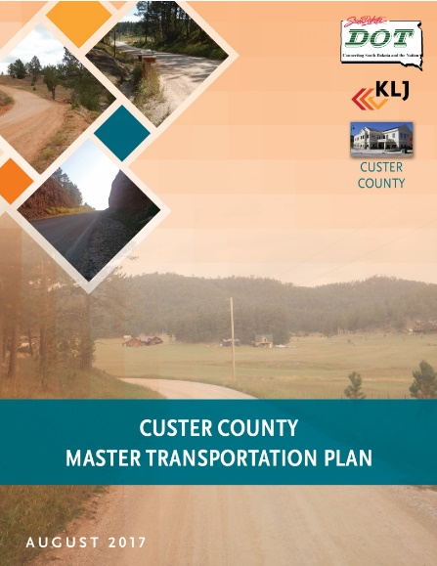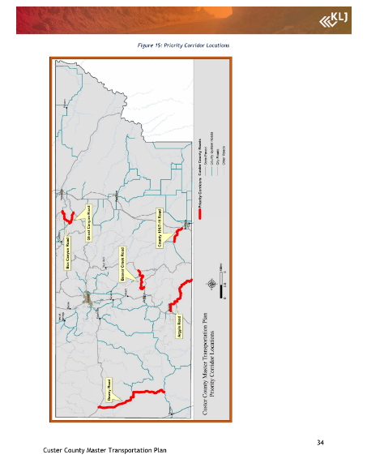
Cost: $100,000
Reference: Gary Woodford, Highway Superintendent, 605-673-5678
Report available at https://dot.sd.gov/media/documents/Final_Custer_County_MTP.pdf.

Davison County Master Transportation Plan – 2015
Cost: $95,000
Reference: Rusty Weinberg, Highway Superintendent, 605-995-8625
Report available at https://dot.sd.gov/media/documents/Davison_County_Master_Transportation_Plan-July_2015.pdf.

Lincoln County Master Transportation Plan – 2019
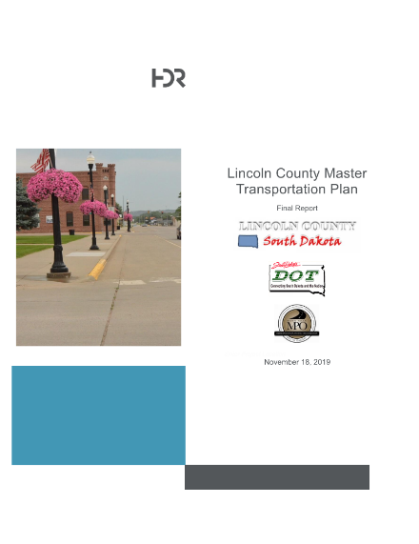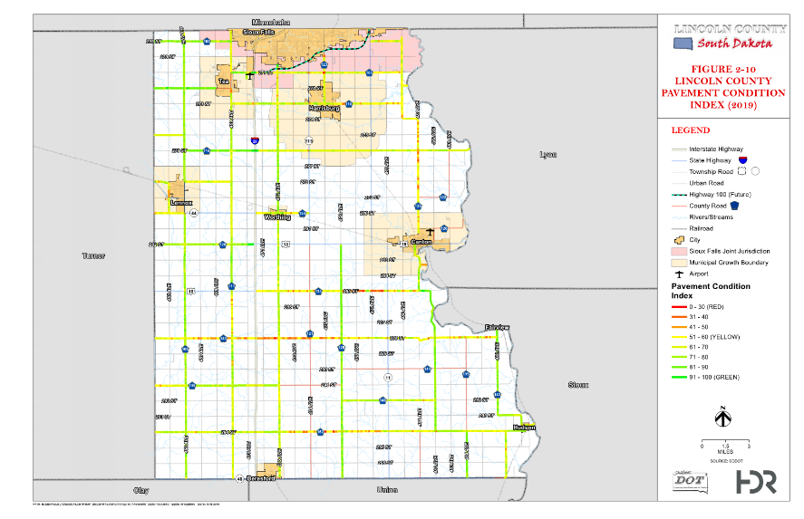
Cost: $150,000
Reference: Terry Fluit, Highway Superintendent, 605-764-5841
Report available at https://dot.sd.gov/media/documents/SDDOT_LincolnCountyMTP_FinalReport_20191118.pdf.

McCook County Master Transportation Plan – 2017
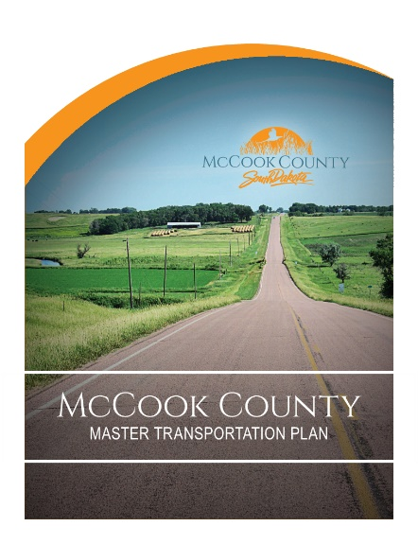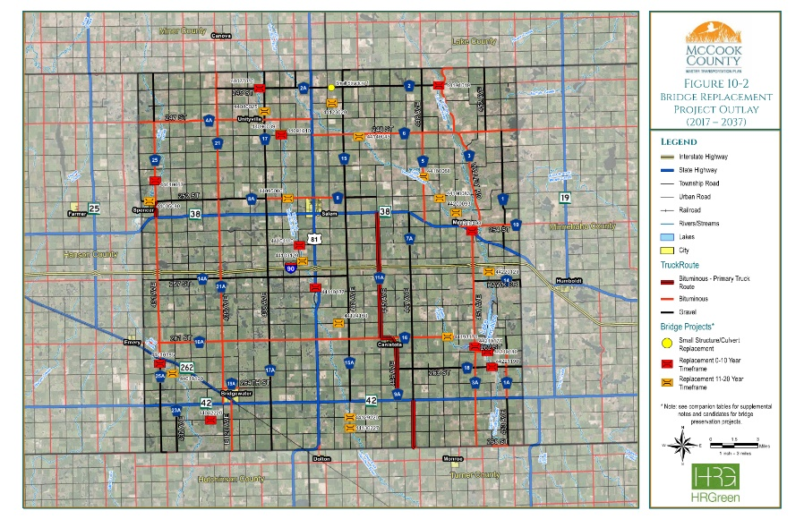
Cost: $100,000
Reference: Mic Kreutzfeldt, Highway Superintendent, 605-425-2731
Report available at https://dot.sd.gov/media/documents/rpt_McCook_MTP_Final_083117_electronic.pdf.

Vermillion Bicycle Master Plan – 2018
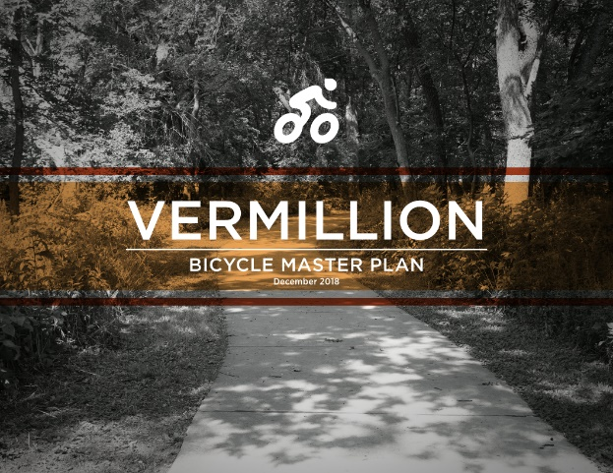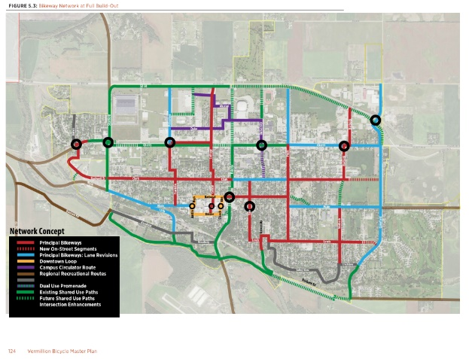
Cost: $125,000
Reference: Jose Dominguez, City Engineer, City of Vermillion, (605) 677-7083
Report available at http://www.sddot.com/transportation/highways/planning/specialstudies/docs/2018_12-3VermillionPlanFINAL-Web.pdf

Walworth County Master Transportation Plan - 2023
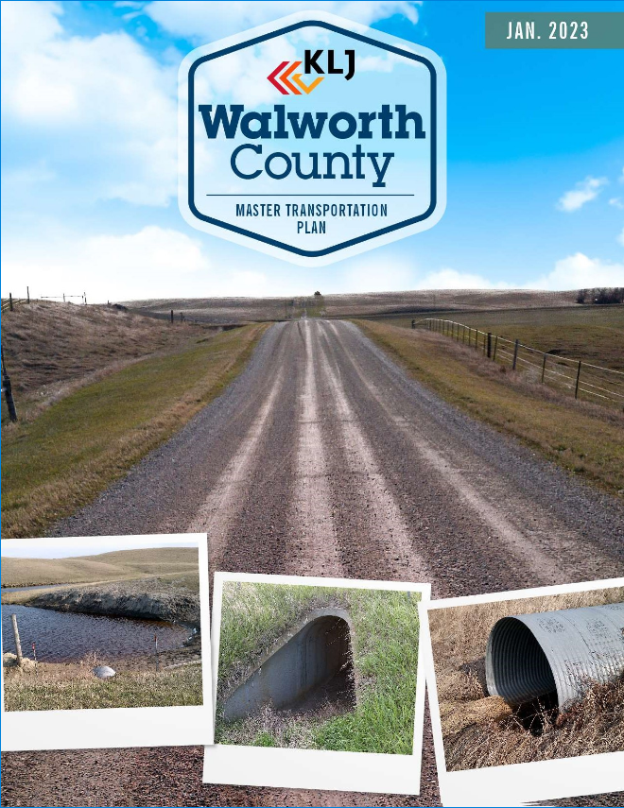 | 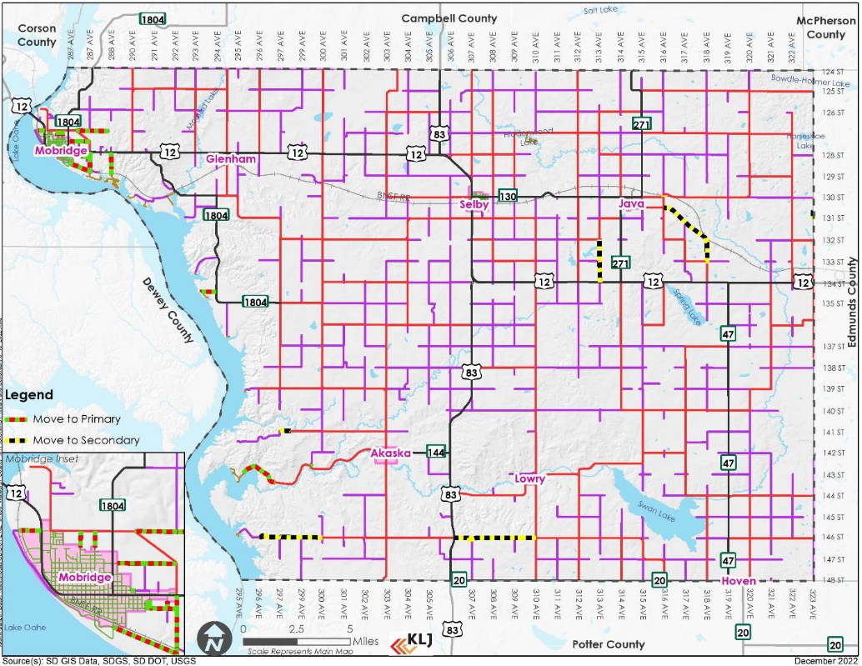
Cost: $150,000
Reference: Gary Byre, Highway Superintendent, 605-649-7299
Report available at https://dot.sd.gov/media/documents/WalworthCounty_Final_MTP%20with%20appendices.pdf

APPLICATION FOR A SPR FUNDED TRANSPORTATION STUDY

APPLICANT:

LOCAL STUDY CONTACT
This contact should be knowledgeable about the study’s intentions and the application as they may be contacted for additional information and will receive all correspondence.

Contact Person:

Title:

Address:

City: SD

Zip Code:

Phone Number:

Email Address:

APPLICATION SUBMITTAL
Name:
Signature:
Date:

STUDY CATEGORY
Please check all that will apply to what is intended to be completed by this study.
Major Street Plan  Bicycle Plan  Pedestrian Plan  Intermodal (Area) Plan  Transportation Revenue | Long-Range (20-year) Transportation Plan  Roadway Standards Development  Management System Development  Access Management Standards Development  Transportation-Related Zoning & Planning Regulation Development
Corridor Study, please provide corridor limits:
Other, please explain:

STUDY INTENTION
Please describe the desired outcome and products the study will produce for your agency and the benefit to your agency and, if applicable, the SDDOT.

PUBLIC INVOLVEMENT
With the use of federal planning funds, public involvement will be required for most activities. Please check each item available for use at local expense (if needed).

ADA Compliant Public Meeting Room(s)
Website
Newspaper(s)
Other, please list: ____________________________________________________________

AVAILABLE LOCAL FUNDING
Please answer only one of the following subsections:

TOTAL AMOUNT OF FUNDING NEEDED:

Complete this section if you already have an estimate of the total amount of funding such a study will cost.

Please list the amount of total funding you believe such a study will take to be completed.

$

Please list the percentage of the study’s total cost (minimum 20%) your entity is willing to provide.
%

AMOUNT OF LOCAL FUNDING AVAILABLE:

Complete this section if you do not have an estimate of the total amount of funding such a study will cost.

Please list the maximum amount of local funding that will be available to complete this study.

$

AVAILABLE RESOURCES
Are there previous study reports, plans, guidelines, or other items available for the consultant’s use in performing this study?

Yes No Don’t Know

If Yes, please list:

Will the outcome of this study result in replacing an existing local plan or guideline?

Yes No Don’t Know

Please submit by March 1st, 2025
To
Katrina Burckhard
SDDOT – Project Development
700 East Broadway Avenue
Pierre, SD 57501
katrina.burckhard@state.sd.us

